1What role did the following communication channels played in your decision to visit?
 | Helped me the most |  |  |  | Didn’t help me
 | 1 | 2 | 3 | 4 | 5
Media (TV/Radio) | 6 | 3 | 5 | 5 | 11
Newspapers / Magazines | 3 | 7 | 5 | 5 | 10
Friends | 12 | 9 | 4 | 7 | 1
College Representatives | 14 | 7 | 3 | 5 | 3
Other | 1 | 3 | 6 | 4 | 11
Please define what other channels did you use – internet - 6; Dobrich website; college ; visit relatives; personal evaluation; mouth-to-mouth; flyers;

What are the main reasons for visiting Dobrich?
My studies 31-69%
Enjoyed previous visits 5-11,1%
Special occasion 6-13,3%
Cultural events 2-4,4%
Other 1-2,2%
Pop concert

Which provided you with the most information about Dobrich prior to your visit, please rate the following options on a scale from 1 ( the least ) to 5 ( the most ).
1 2 3 4 5
Help Desk Services 6 6 8 6 5
Dobrich City Website
(www.dobrich.com) 9 5 7 5 5
College Information
Center 2 2 6 6 14
Friends 4 2 7 11 6
None of the above 6

Through which of the following do you remember seeing or hearing about Dobrich?
Educational visit 19-44,2%
Internet 17-39,5%
Tourist Information Center 1-2,3%
Holiday Guide 1-2,3%
Other 5-11,7%

Have you used a holiday guide, what was it called?
Yes/ state its name – Bulgaria travel guide – 3%
No 32-97%

If you visited the Dobrich website, how satisfied were you with the information provided?
Very satisfied 2-5,7%
Satisfied 10-28,6%
Dissatisfied 1-2,8%
Very dissatisfied 2-5,7%
Neither satisfied nor dissatisfied 7-20%
Never heard of it 13-37,2%
Comments – under construction; it gives enough basic information for the town; I like how data about Dobrich is organized; very poor info; I like the site link placement; I want more; I like the virtual pubs; there can be added more things, but info is enough; much info; they should include more info

How satisfied were you with your visit overall?
Very satisfied 0%
Satisfied 25-75,75%
Dissatisfied 3-9%
Very dissatisfied 0%
Neither satisfied nor dissatisfied 5-15,15%

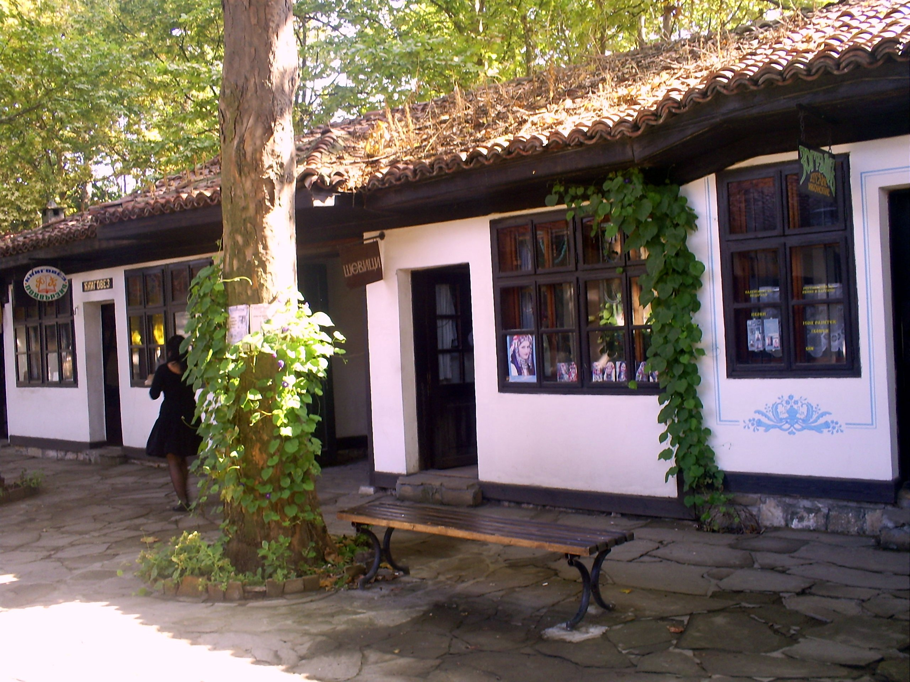
What was the highlight of your visit?
Parties - 3; the people – very friendly and open; business meeting; international college - 6; the spacious center - 2; the beautiful and renewed city park; the central park; lady; night life; entertainment; met some new friends - 4; hotel Bulgaria; the zoo; the pubs; no such; Kobaklaka area;

How would you rate the following Dobrich catering outlets on a scale from 1 ( bad ) to 5 ( excellent ), where 3 is neutral?
1 2 3 4 5
Mehana Gerana 6 7 9 6 6
Pizzeria Seasons 1 3 101010
Pub Dublin 3 5 11 8 7
Chinese Restaurant 4 6 6 10 9
Neshtoto □ 2 8 10 15
Underground 4 4 7 9 9
Bistro “the Lucky Man” 5 6 12 2 4

How did the following live up to your experience?
 | E  X  C  E  L  L  E  N  T | G  O  O  D | F  A  I  R | P  O  O  R | V  E  R  Y  P  O  O  R | N  O  T  V  I  S  I  T  E  D
Old Town of Dobrich | 13 | 12 | 5 | 4 | □ | □
Museum of J. Jovkov | 3 | 3 | 9 | 1 | 3 | 11
City Gallery | 4 | 7 | 9 | □ | 1 | 10
The Zoo | 5 | 5 | 7 | □ | 1 | 14
City Garden | 18 | 11 | 3 | □ | □ | □
Fast Food Pavilions | 6 | 12 | 11 | 3 | □ | 1
Kiosks | □ | 12 | 13 | 6 | 1 | 1
Shops | 4 | 11 | 13 | 4 | 2 | □
Staff | 2 | 11 | 7 | 7 | 6 | □

Do you think that Dobrich is expensive compared to other tourist destinations?
Expensive The same Cheap
Catering/Hotels 7 19 9
20% 54,3% 25,7%
Shops 6 27 1
17,65% 73,5% 2,94%
Entertainment 4 17 14
11,42% 48,58% 40%
Overall Value of
Money 4 24 6
11,76% 70,60% 17,64%

If anything about your visit failed to meet your expectations, please briefly tell us why?
Nothing failed to meet my expectations. I haven’t heard nice words for Dobrich and it turned to be true; not many things to do or visit; I expected more from the signs placement; tell to reception in hotel Bulgaria that there are cock-roaches in my room; expected Dobrich to have Hard Rock Café; the people are not so welcoming and nice as I expected; the people are too noisy and very ungrateful; Dobrich lacks a good cheap 24 hours food boutique; nothing - 2; no comment - 2; stupid people; I’m not sure; expensive service, poor quality; none did; no – 2;it is too quiet and lacks intertainment places for the young people; only 1 cinema hell.actually a room not a hall; not much entertainment; the first that has to be improved is the bus station of the town, because it is very durty; everything went on fine

Please use the space bellow if you have any comments or suggestions to improve the visit.
More attractions especially for young people; Tour guides! As in books not people; change your tourist destination; no comment - 4; the service in the cofe shops and houses and night bars have to be improved; I would like to see improvements in bus transport; lower the prices; don’t go to Dobrich; better services in entertainment; maybe tour guide will be helpful; make a smile on people’s faces; no; hire more young people in the city concil; more attractive entertainment for young people; it’s better to have more international fairs, festivals, concerts. It will be more famous;

How would you rate Dobrich compared with other destinations?
The Best 0%
The Same 14-39%
Worse 13-36,1%
Don’t Know 1-2,7%
No Comment 8-22,2%

Do you think that the hotels / other accommodation places need
improvements?
Yes 25-71.43%
Why?
Low level of staff services; more English; the service is very poor – 5; not enough comfortable; expensive – 4; change communication style; need better personnel; they are not good enough to live in there; the rooms need upgrades; low quality; cockroaches; change the staff; the rooms in hotel Bulagia need renovation; the hotel rooms suck; the visitors are becoming more and more demanding concerning hotels; many; there are no appropriate places for students; for being more comrotable; need staff improvement

No 10-28,57%
Why?
Because I was happy with my hotel; cockroaches; not enough hotels; everything is nice; they r ok; good enough; I bought a flat here; have everything nessecary; they have everything needed for the stay

Describe Dobrich with three words.
Noisy - 2; regular; boring - 11;
small – 8; green – 2; grey – 5; interesting; fun – 5; gipsy king; poor toward entertainment; not rich/poor - 3; average; simple; dirty - 4; warm; cold in the winter - 2; beautiful - 3; provincial; peaceful - 3; expensive - 3; nightlife; nice - 3; colorful - 2; windy; desert; strange; park; center; compact; cheap; people; nature - 2; ok - 2; ancient; exciting; shiny; quiet; calm - 2; eventless; sleepy; lively; very very bad; relaxing; monotonous - 2; rich; light; friendly;

Are the road signs on an appropriate places and easy to follow?
Yes 20-60.60%
No 13-39,40%

ABOUT YOU:

Please indicate your gender:
Male 18-51,43%
Female 17-48,57%
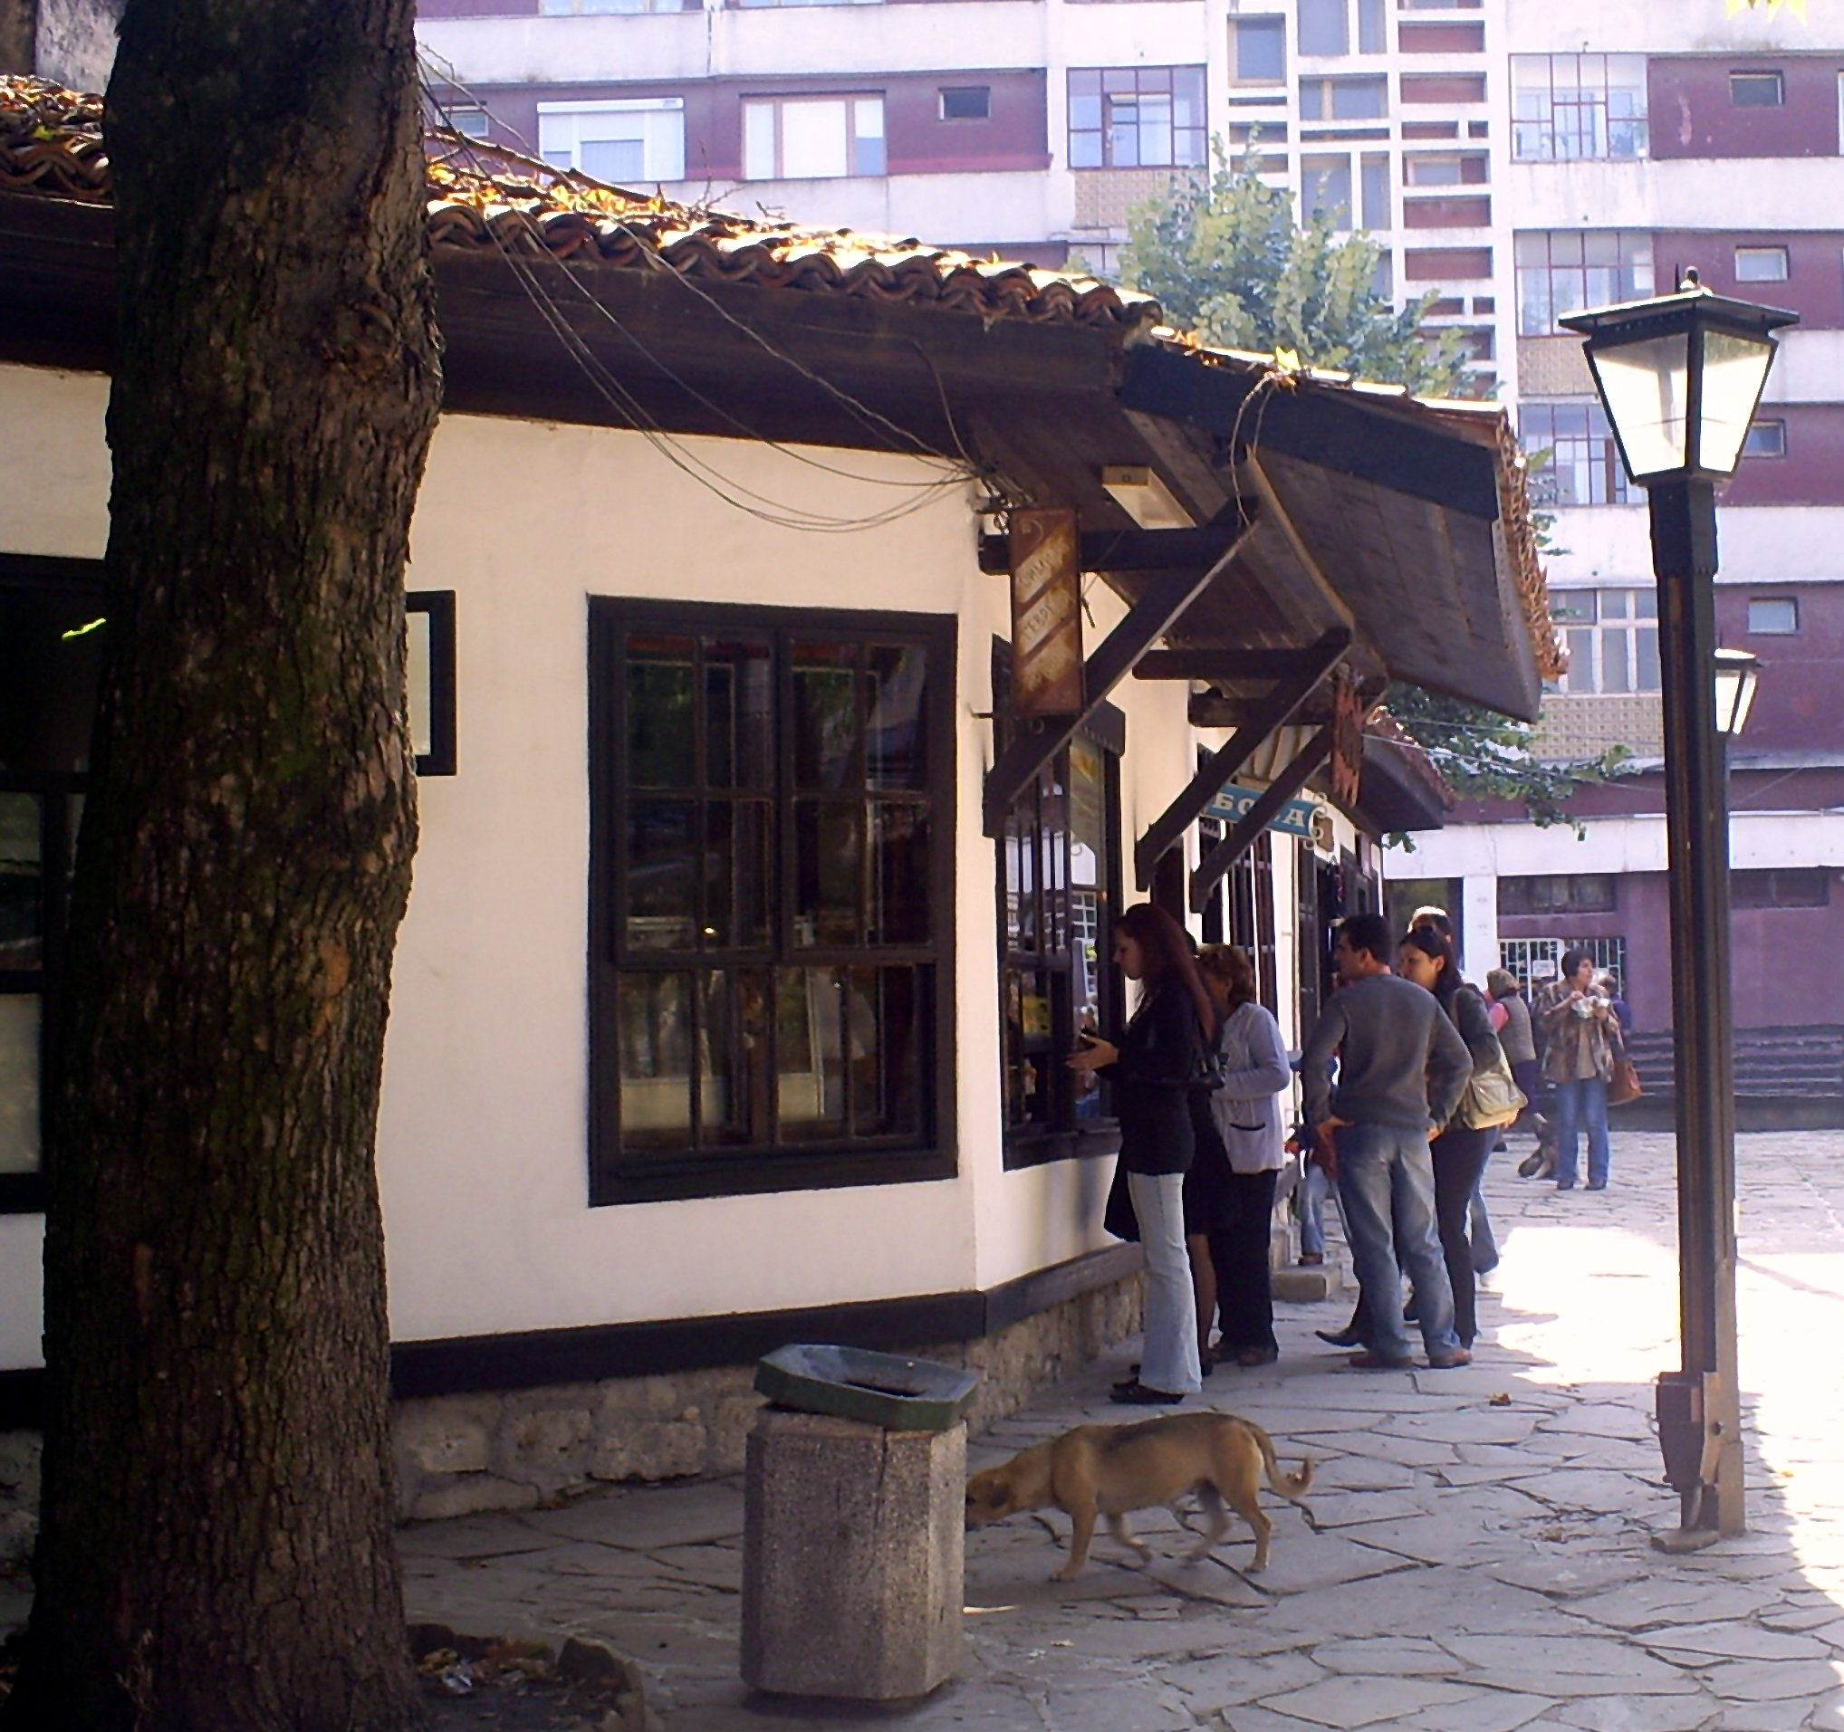
Your age bracket:
18-24 27-77,14%
  - 8-
22,86%
Over 35 0%

Please state your:
Home country – BG - 30, Ned, Albania
Country of Residence – BG - 32, Ned

