E-Marketing Assignment

The Battle of The Pixels

DreamWorks Animation Studio
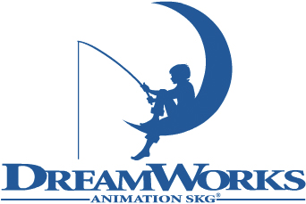

Pixar Animation Studio
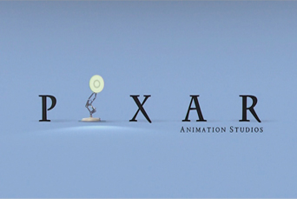

Alexandrina Pavlova Student Number: XXXXXXX
Table of Contents
Introduction 3
Websites 4
DreamWorks 4
Pixar 4
Overview 5
DreamWorks 5
Pixar 6
Online Presence 7
DreamWorks 7
The Web Design - Overview 7
User Friendliness 8
Content 10
DreamWorks’ Mission Statement. 10
Coherence with Mission 10
Pixar 11
The Web Design – Overview 11
User Friendliness 12
Content 13
Pixar Mission Statement 13

Introduction

The Internet, bearing birth for the first time in the 1950’s, as a mere creative thought in the heads of a handful of visionaries, and coming to reality for the first time in 1969 by connecting four computers in an university, today is one of the primary means for communication and is slowly evolving into a single click economy that in the future will take away the ability to walk from people. As a result of that the Internet has become the rivalry playground for a lot of companies all trying to steal a piece of the cash cake. Reading through this report you will take a glimpse at how two animation companies are doing in their quest for popularity in terms of a website comparative analysis.

Websites

DreamWorks

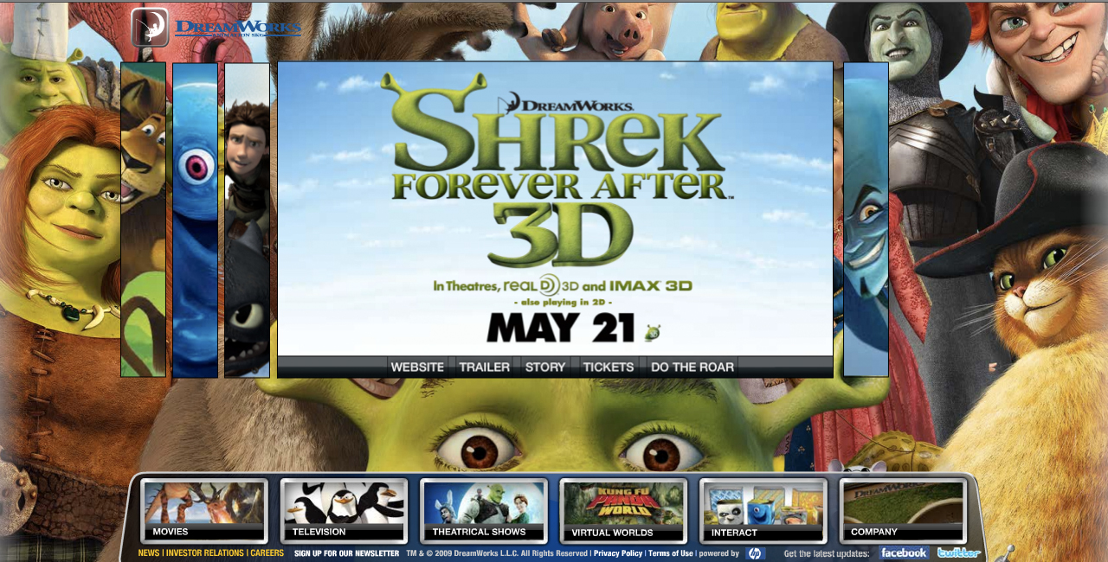

Pixar

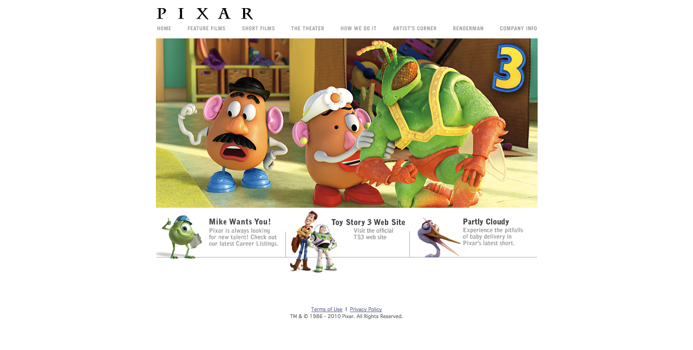

Overview

DreamWorks

DreamWorks is a Hollywood movie studio that was founded in 1994 by the media moguls Steven Spielberg, Jeffrey Katzenberg and David Geffen and to date has its headquarters in Universal City, California, United States. The studio has been in the movie making business for quite awhile and since its foundation it gave birth to award wining movies like Gladiator, American Beauty, A Beautiful Mind, Saving Private Ryan and many others.

DreamWorks is a company with a turbulent history and although it has produced quite a few award-wining movies, what really made the company famous is its DreamWorks Animation Studio. Although many think that the DreamWorks Animation Studio is a subsidiary company of DreamWorks, it is actually a DreamWorks department that is completely dedicated to the production of computer generated animation movies. The official title of the studio is DreamWorks Animation SKG and also has its own unique logo that is adapted from the original DreamWorks logo.

To date DreamWorks Animation SKG has produced twelve animated movies with in averaged income 139 million dollars per movie.

Pixar

Pixar Animation Studios is an American CGI production company based in Emeryville, California, United States. Initially Pixar started out as a Hardware company that had planned on creating high-end visual processors that would have the government and the medical world as the company’s major clientele, and this venture nearly caused them bankruptcy, but in 1986, Steve Jobs bought Pixar for 10 million dollars and since then Pixar officially became what people know it to be today, Pixar Animation Studios, which of 2006 belongs to Disney.

Pixar is one of the most critically acclaimed film studios of all time. It is best known for its CGI animated feature films and to date the studio has earned twenty-four Academy Awards, six Golden Globes and three Grammys, among many other awards, acknowledgements and achievements.

To date Pixar has released ten featured movies totaling a summed income of 5.5 billion dollars worldwide and today the name Pixar has become synonymous with “excellence in animation”.

Online Presence

DreamWorks

The website of DreamWorks Animation Studio comfortably resides within its web address www.dreamworksanimation.com. It is the first result that pops up in Google and Yahoo, when a search query is used with the keyword “DreamWorks”. It is an interesting fact to note, that DreamWorks is indexed first with its animation department and not with its official company site. This can only show that the company is aware that people do not recognize the name DreamWorks for its real acting movies and instead people associate it with computer animation.

The Web Design - Overview

The website is purely flash based and upon navigating to the site people are presented with an animation of the DreamWorks logo which is actually the loading screen. Since flash content tends to be a bit heavy on computer processors it takes up from about 3 to 5 seconds for the website to load on a Macintosh laptop with a fast Internet connection. After the loading process is complete the website finally opens up and people are presented with five animated modules with trailer videos of DreamWorks’ most recent movies, as the most recent one opens up automatically.

Most of the panels contain their own custom navigation and from there visitors can choose to either watch a trailer of the movie, visit the personal website of the movie, read a short story or buy online tickets.

The main navigation of the website, also flash based, is located in the bottom and each of its buttons are interactive. The navigation bar contains six buttons, three of which are commercially oriented, two that are user oriented (just for the amusement of the visitor) and one that navigates to the company profile.

In general the website is quite appealing to the eye and to some extend fun to play with, that is if you are a true fan of DreamWorks and are familiar with all of its animation characters.

User Friendliness

The website of DreamWorks has a very welcoming, warm and colorful appearance but sadly this is about it when scaled down to the experience it provided while doing the research for this assignment. The website is very flash heavy to the point where the video previews annoyingly begin to stutter and take out all the pleasure of viewing the goodies that the site has to offer. The website has a lot of interactive features and in general it does a really good job at providing an easy to use interface, but getting from point A to point B is a painful experience when having to go through choppy animations that literally fry your laptop’s processor.

However if you are in a possession of a very powerful computer, and not a laptop, I assume that the website will offer a completely different experience. The flash interactive interface does a really good job at keeping 95% of the content in one page and when moving from panel to panel the transitions between point A to point B is a sleek fade in and fade out effect. You can view an example on the next page.

So how does DreamWorks’ website perform. To be honest if I had a desktop computer and not my powerful Macintosh laptop I am sure that I’d have a lot of fun with the website. The content of every button you click appears in front of your eyes, it is easy to keep track of where you are and the previews are hilarious. So under that condition DreamWorks’ website really is a masterpiece.

However having in mind that we live in a fast paced globalized world, the experience of the Internet is actually brought to people by handheld devices and laptops. I think that, although really nice looking, the website does not need so many flash animations. DreamWorks can improve on its design by making the website lighter and faster to load. This will surely keep traffic on the website rather than users switching to YouTube in order to view the previews.

Transition Between Content

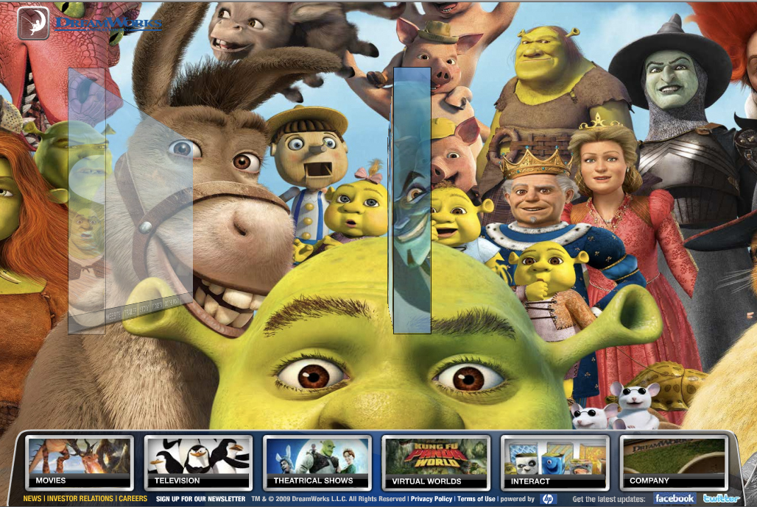
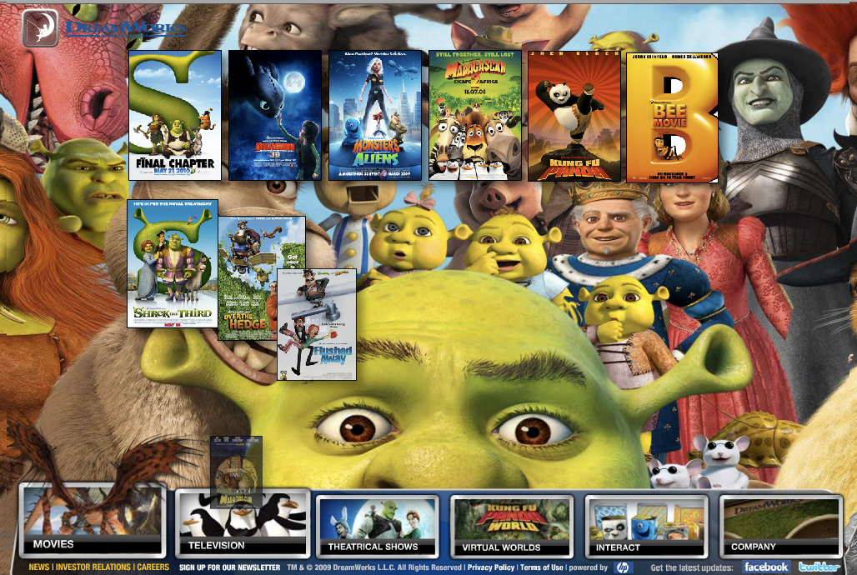
Content

The content of the website is 90% visual aids, meaning it consists of animations and videos. There is a small portion in the “Company” section where the company’s profile is situated, that is text based.

I cannot miss to give a positive remark here, although it is expected from such a web site to mainly have video content, that DreamWorks has done an excellent job with its content. The most important section of the website, that actually houses 2/3 of the whole website content, the previews, has an integrated option with each preview, that allows you to directly order a movie or buy tickets if it is being featured in theaters. What makes it so amazing to me is that the website does an amazing job in marketing their movies. What is actually, from first glance, a page with movie previews in the end it turns out to be a movie web shop. Stripping the visitors of their awareness that they are actually being sold stuff is something that a website should really be proud of.

All that being said… all the glamour kind of fades away a bit since the flash content made my laptop load the previews forever and I actually switched to YouTube in order to see them. Most of the Internet users do not have patience. With long loading times visitors tend to bounce off the website to another location. That is a potential sale missed.

Point for improvement – The website needs to decrease loading time for video content.

DreamWorks’ Mission Statement.

DreamWorks Animation SKG is devoted to producing high-quality family entertainment through the use of computer-generated (CG) animation. With world-class creative talent and technological capabilities, our goal is to release two CG animated feature films a year that deliver great stories, breathtaking visual imagery and a sensibility that appeals to both children and adults.

Coherence with Mission

DreamWorks has devoted itself to deliver two CG animated movies per year and as this is the only measurable item in their mission, they have stuck to what they said 100 percent. Proof for that is their featured film releases. The Road to El Dorado – March 2000, Chicken Run – June 2000, Shrek – May 2001, Spirit: Stallion Of The Cimarron – May 2002. Without having to list all of their movies the thread goes on like this with all their releases. No points for improvement here.

Pixar

Pixar’s website is located at www.pixar.com. Just typing Pixar in any search engine will get you to their website.

The Web Design – Overview

The website of Pixar Animation Studios consists of a very clean design on a white background with just 4 elements on it – Pixar’s logo, Site Navigation, Header/Single Cell Table and an element below the header that I call bottom navigation.

The website loads within half a second and the loading speed is constant through out the whole website. All content is displayed in the center of the website in a fixed 705 wide and 315 high pixel dimensions, which makes the site viewable on screen resolutions of 800x600 pixels. Even ancient computers will be able to load it without having to display it with additional scrollbars. It even almost fits within a word page.

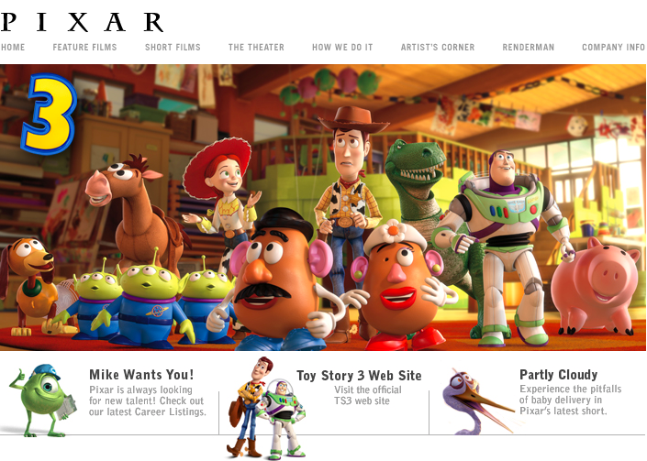

User Friendliness

The design concept that Pixar has chosen for their website makes it into something that even a baby can use. The visitors of the website are not bombarded with tons of visual aids, quite to the contrary, users have just two options – the Main Navigation and the bottom navigation. The main navigation is styled in gray and has a mouse over hover styling effect of a darker grey. When clicking on a button it automatically switches colour and turns black hinting the visitors to where they are within the website. Even without the navigation effects it is very easy to keep track of where you are since every page of the website is generic and at the same time unique. This has been achieved by keeping the dimensions and elements of the website fixed for every page combined with perfectly matched content. For example if you click on Feature Films you will see Feature Films only, nothing more, if you click on Short Films you will see Pixar’s Short Films and that is it. Some pages contain more content that the specified content area of the website can fit. Users can easily transition from point A to point B by using the scrolling arrows that are located under the table.

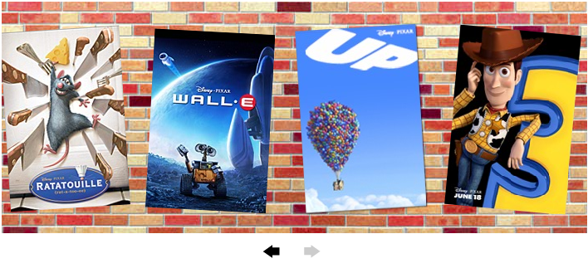

Pixar has taken into account also handicapped people and optimized its website so that it can be used by anyone. Although I used a “text to voice” program for the first time, I had no problem using it (maybe because I can see where the buttons are in regard to blind people). All of Pixar’s website elements have an “alt” attribute that is used to help such programs interpret the content of a website and help blind people navigate around it..

Pixar’s website provided me with a wonderful experience and although I wished it provided a bit more in the area I am about to write about next, as far as it goes to user friendliness there is nothing more you can ask for.

Content

The content of the website is very similar to the one of DreamWorks which is to be expected having in mind in what niche the two companies are.

Throughout the website 90 percent of the content is visual consisting of video previews and pictures and the only text oriented page is the “Company Info”.

Although, in my opinion, Pixar has done a great job in presenting visually appealing, well organized and strictly limited to the page’s name content (huge plus for me since a lot of websites tend to use misleading names and content just to spam) the website has a flaw. All of the video previews require QuickTime 5 video player and I as a Macintosh user had no problem with it, but still the majority of the Internet users are Windows based and have Windows Media Player Instead. I can imagine that Steve Jobs wants everybody to switch to Mac but to distribute all of the websites free stuff through iTunes to me is foolish.

Having in mind that I wouldn’t bother at all to go through the hassle of downloading and installing two different programs just to see a preview or download a soundtrack, and I think most of the people won’t, Pixar’s content to me suffers a great deal just because of that.

Point for improvement – Video content can be made compatible for view with the standard players for the web that everybody has.

Point for improvement – Downloadable content can be distributed through a simple zip download. The iTunes medium can be kept for Mac users and for those who use iTunes for Windows but not as the primary and only choice.

Pixar Mission Statement

Not Available.

Point for Improvement – Not obligatory but Pixar can invest a little time in making available to the world what their mission is.

Conclusion

In the movie making business both companies are a huge success and enjoy a handful of fans and popularity with Pixar, for now, deemed to be slightly better of the two.

Both companies have really wonderful websites with little irks and quirks here and there, and if I have to be critical for me their overall score would be around 8 out of 10.

Both websites are aimed at showing the world what they do best with DreamWorks’ site being slightly commercial. Certainly it is not bad to squeeze and extra buck but I think the websites should aim at marketing their movies mainly for the big screen, where the big money are made, and in that respect my personal winner is Pixar.

Mogul - An important or powerful person, esp. in the motion picture or media industry.
CGI - Computer (or CGI animation) is the art of creating moving images with the use of computers.
Feature Film - A film made for initial distribution in theaters and being the "main attraction" of the screening.
Trailer – Short video clips that are usually part of a longer piece.
iTunes is a proprietary digital media player application, used for playing and organizing digital music and video files

